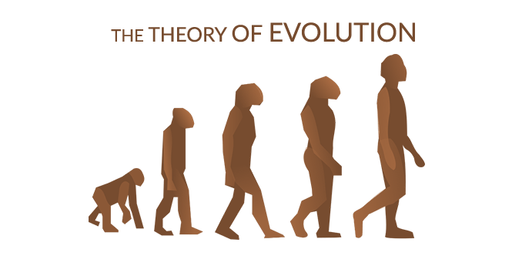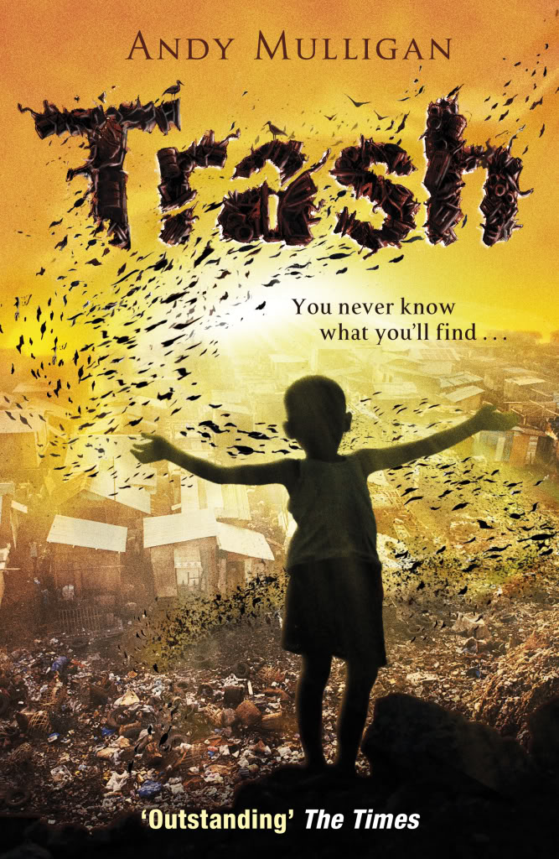

**Year 6’s learning this half term:**

This term, Year 6 will be focusing on the Human Rights global theme. They

will be using the text ‘Trash’ by Andy

Mulligan to learn about the inequalities in Brazilian society. They will learn

about the story of a young boy whose life is changed when he discovers

a wallet full of money when searching through a dumpsite. The children

will be writing descriptive narratives and a character description linked to

the core text.

**Curriculum:** Continuing their geography skill and understanding, this term

the children will be consolidating the geographical skills gained last half term and using them in conjunction with their oracy skills on presenting. The platform this learning will take place on will be to create a new charity platform and online marketing. This will also be using a lot of the children’s IT and computing knowledge and learning new skills in this area.

**Science:** During the Autumn Term Year 6 will focus on Living Things and Evolution. They will start by learning how to classify different living things and discuss different types of plants and animals that live on Earth. During the second half of the term, they will discuss the theory of evolution and how plants and animals adapt and evolve to suit their different environments. We will also learn about the life of Charles Darwin and how his theory impacted societies thoughts about plants and animals.

**Maths:** Maths lessons this half term will focus on the children developing their understanding of fractional parts and calculating fractions of amounts before progressing to calculating fractions using a variety of methods. Through arithmetic, they will revise the four operations and practice a range of calculations. The children will be given a range of fluency and reasoning activities throughout the term.

**Music:** This half term we will be focusing on our listening skills, investigating a range of music through our choice of songs for our Winter Concert.

**Welcome Back!**

Welcome back everyone! We hope you have had a lovely half term break and enjoyed making lots of memories! We are all looking forward to a very exciting term and the events taking place in the lead up to Christmas. The children had a fantastic start to the year and we know this is going to continue during the next half term.

If you wish to speak to us, please book an appointment with the school office. You can also contact us via email [smorton@woodhill.grennwich.sch.uk](mailto:smorton@woodhill.grennwich.sch.uk)

, [asparrow@woodhill.greenwich.sch.uk](mailto:asparrow@woodhill.greenwich.sch.uk) and [dmccarey@woodhill.greenwich.sch.uk](mailto:dmccarey@woodhill.greenwich.sch.uk)

**School value:**

Our school value for this half term is RESPECT. This value will be explored through assemblies, circle time sessions and throughout our daily routines.

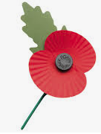

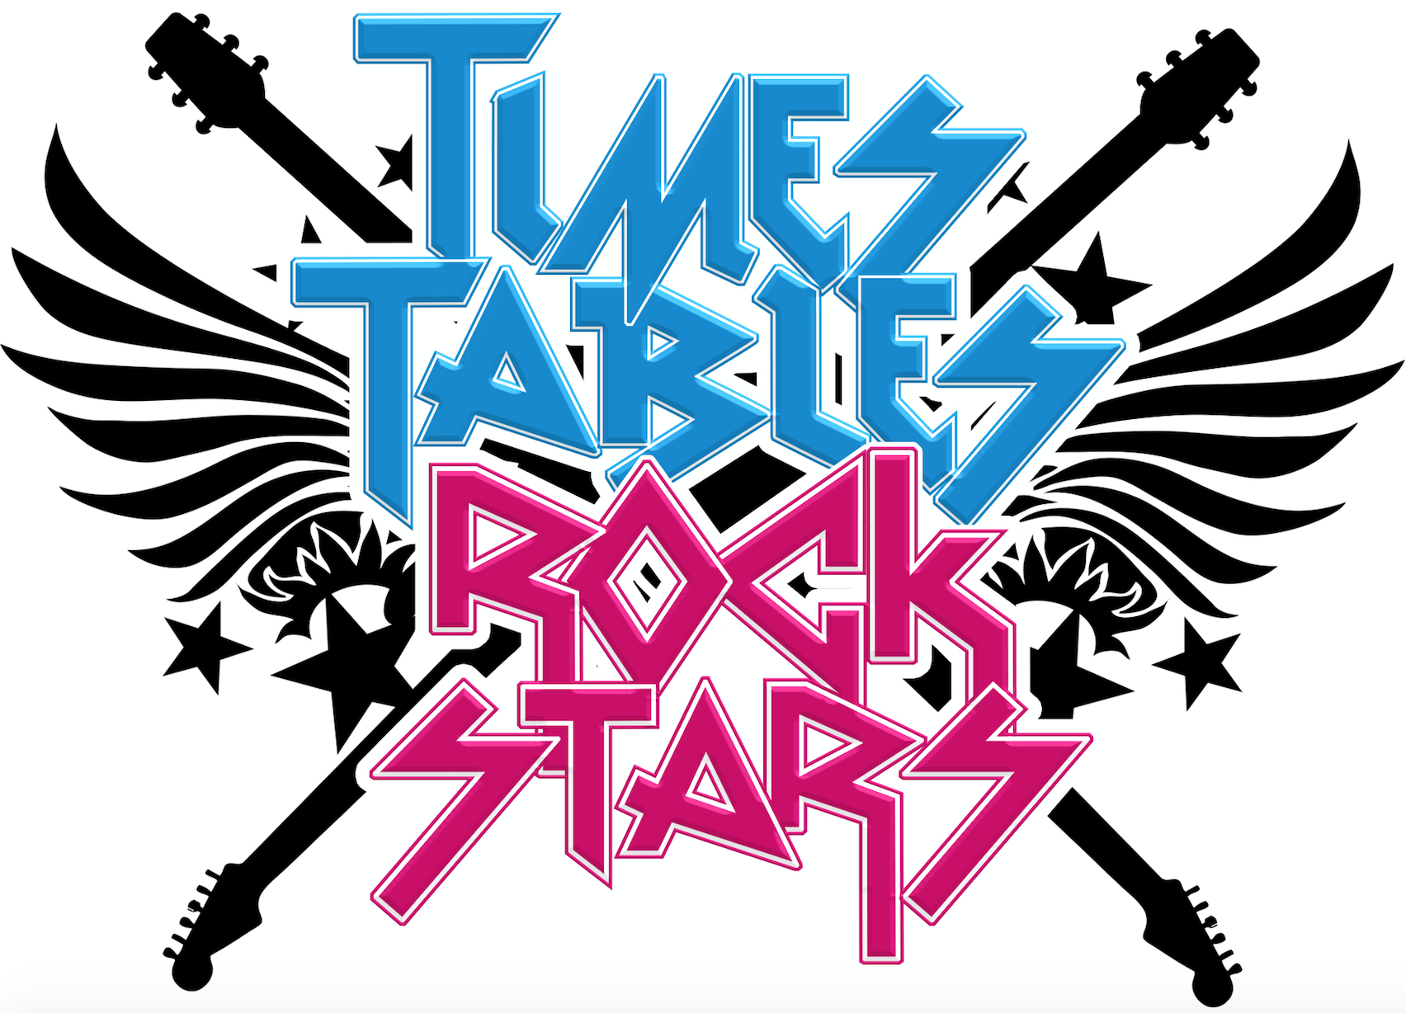

**Reading**

Whole class reading will take place **every day.** The children will work on a range of reading skills and strategies including deduction and inference. There will be a big focus on reading for enjoyment and using the oracy framework to engage in discussions about reading themes.

The children will change their home reading books when they have finished. They can choose a book from home to read or take a book from the book corner. It is important that the children try to choose books that stretch them and help to improve their vocabulary.

Please try to read with your child every day at home for ten minutes. Please feel free to give feedback about how they got on, or the difficulty level of the reading book. We appreciate all parental feedback.

**Dates for the Diary:**

* Remembrance Assembly - 11th November
* Parents Evenings – Tuesday 9th November Wednesday 10th November
* Winter Concert – Tuesday 14th December
* Christmas Holiday - 16th December

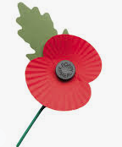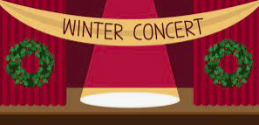

**PE:** This half term, PE will be learning the skills for tag rugby before applying them to a game situation.

**Computing:** This will be linked to Curriculum work this term and the children will be planning and creating an interactive documentary and continuing to develop their computing skills using Purple Mash.

**Art:** The children will be creating art linked to their core text ‘Trash’, focusing on the theme of a city scape and the different ways you can create the landscape of a city.

**French:** This term the children will be learning how to talk about clothing in French.

**RE:** This half term in RE the children will be learning about Christiantiy and their festivals.

**General Information**

**PE:** PE will take place once or twice a week, Monday and Thursday. Please make sure children bring their PE kit to school on the day they have PE.

**Reading Record books**: Please encourage your child to write any books they read in the reading record book.

**Water bottles:** Please ensure your child brings a clean, suitable water bottle into class with their name on.

**Times Tables:** It is important that children in Year 6 continue to practice all Times Tables in order to improve their fluency. They should also use their Times Table Rockstars account whenever possible to practise.